NC Highway Patrol Medical Office
Supplemental Health History Form – Summer Program
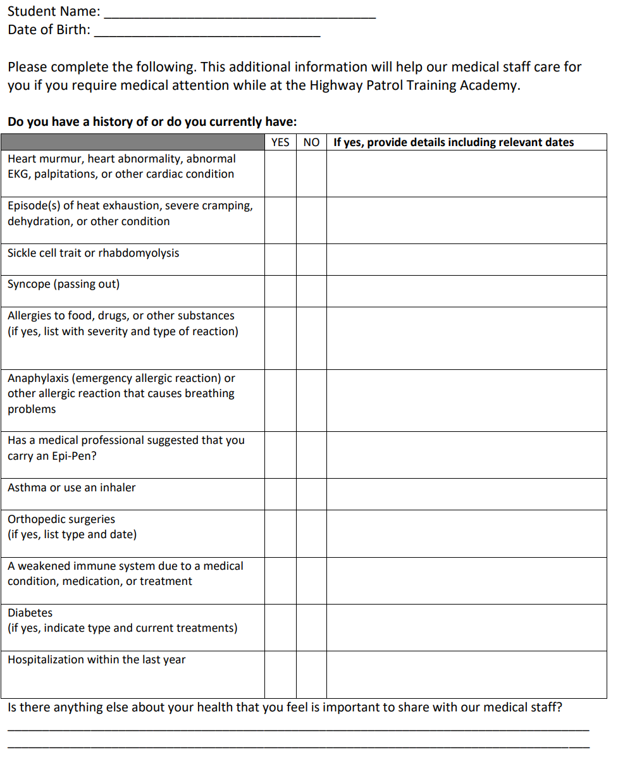
Questions or concerns may be directed to:
NCSHP Medical Office – 919-662-4490 or medicalappointments@ncshp.gov
Address: 3318 Garner Rd., Raleigh, NC 27601

